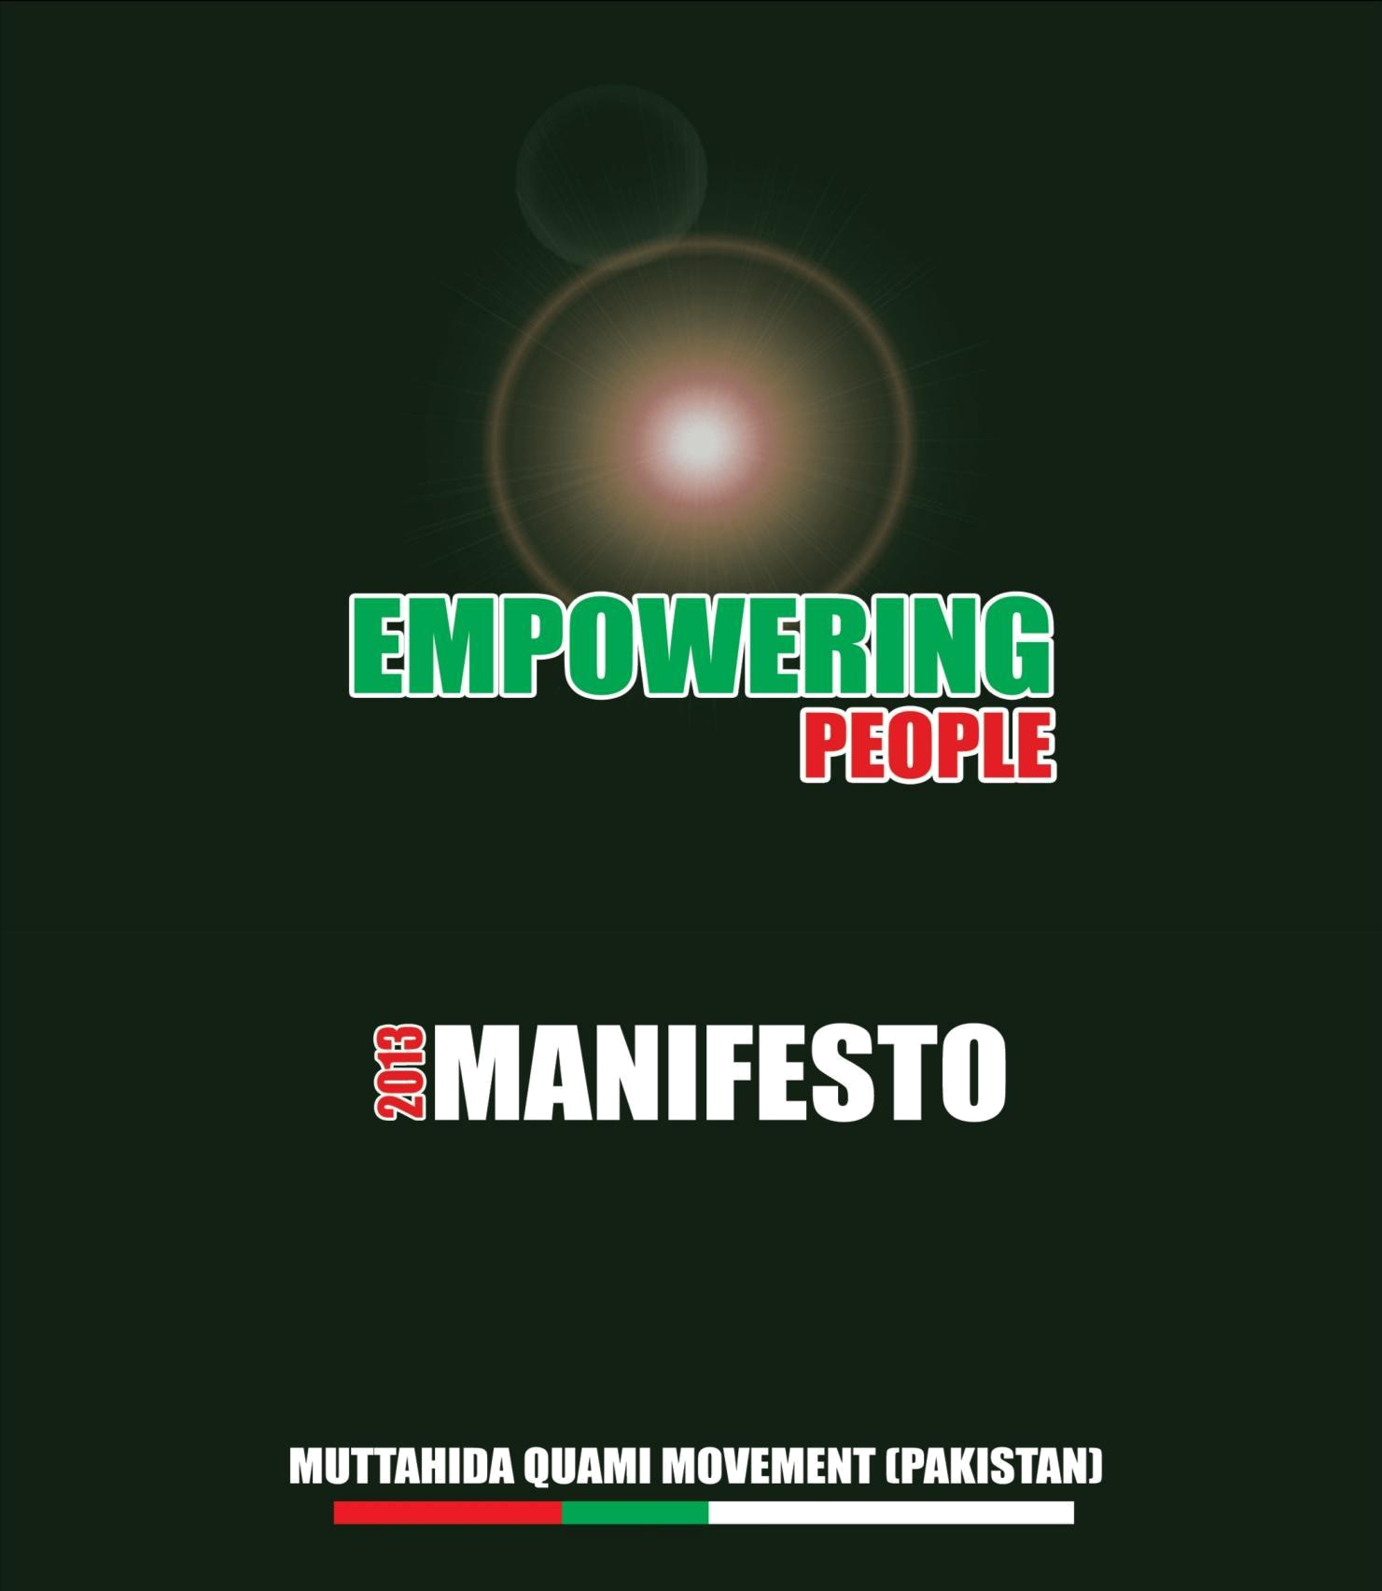

EMPOWERING PEOPLE

MQM MANIFESTO 2013

VOICE OF THE MASSES

"it's good to see a transition from one democratic dispensation to another, yet the fate of the people has not changed and the biggest democratic deficit of democratic era was the Local Autonomy and Participatory Democracy. Future of Democracy and common men in Pakistan cannot be secured without the effective third tier of the government i.e. Local Governments"

Altaf Hussain

Founder & Leader

Muttahida Quami Movement (Pakistan)
Table of Content

 | No. |  |  | Subject |  |  | Page No.
 | 01. |  | Education |  |  | 05
 | 02. |  | Health |  |  | 07
 | 03. |  | Economy |  |  | 09
 | 04. |  | Governance |  |  | 11
 | 05. |  | Terrorism |  |  | 12
 | 06. |  | Poverty Alleviation and Unemployment |  |  | 14
 | 07. |  | Industries and Labour Sector |  |  | 15
 | 08. |  | Energy |  |  | 16
 | 09 |  | Participatory/Grass-root Democracy and Local |  |  | 17
 |  |  | Autonomy (Empowerment for All)
 | 10. |  | Urban Development |  |  | 18
 | 11. |  | Foreign Affairs |  |  | 20
 | 12. |  | Agriculture & Irrigation |  |  | 20
 | 13. |  | Judiciary |  |  | 23
 | 14. |  | Media and Freedom of Expression |  |  | 24
 | 15. |  | Information Technology |  |  | 24
 | 16. |  | Overseas Pakistanis |  |  | 26
 | 17. |  | Provincial Autonomy |  |  | 27
 | 18. |  | Human Rights, Women, Children and Non Muslims |  |  | 27
 | 19. |  | Environment |  |  | 29
 | 20. |  | Youth |  |  | 29
 | 21. |  | Sports and Culture |  |  | 30
 | 22. |  | Social Welfare |  |  | 30

MQM MANIFESTO 2013

PREAMBLE:

MQM is the only political party in Pakistan which represents and comprises of ninety eight percent working, middle class and poor masses of the country who are presently down trodden, disadvantaged and exploited by the two percent ruling elite.

MQM has revolutionised politics in Pakistan its elected representatives and office bearers are chosen by ordinary party members/workers and people on merit from constituents level not by virtue of being born in a feudal family or political dynasty.

The prevalent feudal system in Pakistan is the main obstacle in the progress of the country and the prosperity of her people. Due to this obsolete system a genuine democracy could not establish in the country and the people of Pakistan could not get their due rights, social justice, equal opportunities, rule of law and real participation in the affairs of the state.

MQM is struggling to abolish this obsolete system and introduce participatory democracy, merit based bureaucracy and independent judiciary wherein the State shall promote social and economic wellbeing of the people in order to establish a truly democratic, progressive and egalitarian society in the country where all citizens have equal rights irrespective of their caste, colour, creed, language, ethnicity, gender, belief and religion.

MQM believes in Realism and Practicalism as enunciated by Mr. Altaf Hussain, the founding leader of the party. MQM is against all types of terrorism, religious extremism and is struggling for religious, sectarian and interfaith harmony.

The cherished goals of MQM are eradication of political authoritarianism, abolition of feudal system, promotion of cultural pluralism, devolution of power to the grass root level and to achieve full provincial autonomy and a completely devolve local government system. MQM believes in induction of common man in the power structure to provide opportunity to economically and socially deprived people-“empowerment for all” for a better and safer life for today and tomorrow.

MQM hopes that the people of Pakistan will support the MQM to achieve these cherished goals.
1- EDUCATION:

Education is the fountainhead of all technological progress and social development, and technology is the key to economic growth. It combats, unemployment, provides social equality, awareness, tolerance, self esteem and especially counters the spread of cultural and plural diversity. Like other social sectors, Education too is riddled with manifold problems.

MQM thus proposes to:

- Gradually increase education expenditure from 2.2% to 5% of the GDP, whereas Provinces need to allocate 20% of their revenue budget to education sector.

- Present dual system of education be abolished, not to degrade the privately

managed institutions, but to upgrade the Urdu medium public sector educational institutions at par with the Grammar and English medium institutions.

- Measures be taken to drastically revise the syllabi of the public sector and Urdu medium schools for a uniform syllabi in all the educational institutions.

- Madaris (religious seminaries) be provided incentives to bring such institutions at par with the main stream of education at national level.

- Enrolment of children between the age 5 to 16 years be launched at massive scale both by the government, the civil society and especially NGOs. Since Sindh Assembly on the initiative of MQM has already enacted a Bill in conformity with the provisions of Article 25-A of the Constitution, it is high time that all the provinces follow suit and take measures on war-footing to make education compulsory and free for the children of this age.

- Provinces shall supply free books, uniforms and transport facilities to school going children.

- Introduce an evaluation system through Key Performance Indicators (KPI) which need to be monitored by the Community Management Boards at taluka/tehsil and district level to sustain the growth of literacy and standard of education and to ensure minimal dropout rate and no corporal punishment to the students.
- Every Province need to draw plans for the refurbishing of school buildings, provision of drinking water, washrooms, boundary walls and security arrangements.

- Actively encourage ‘adopt-a-school’ policy to ensure that philanthropists play an active role in promoting free education

- Put on fast track the moto, ‘enter to learn’; and ‘go to earn’ especially in vocational schools

- Launch extensive training and refresher courses for primary and secondary school teachers

- The examination system will be made more transparent and rigorous.

- Grants and scholarship will be provided to such brilliant students who show best results and seek higher education both at home and abroad, especially for students who come from financially disadvantaged background.

- Official grants for professional colleges, like medical and engineering- so as to lessen the fee-burden for those poor students who cannot afford to bear the burden of high-fees.

- Reintroduce/ strengthen the role of elected students unions.
- Establish a network of public libraries, including digital libraries

MQM is determined to undertake all above measures to meet the challenge of education emergency. By developing across the board consensus, MQM will work on legislation, provision of additional financial resources, enrolment drives, reforms in syllabus and curriculum and most importantly the national and international organizations and foreign expertise to formulate, implement and ensure optimal utilization of funds for the growth of our Nation through a world class education system.
2- HEALTH

MQM believes that access to a quality healthcare system is a right of every Pakistani regardless of his/her income level and social status. MQM stresses upon primary and preventative healthcare, instead of the tertiary healthcare, which has been the main stay of the Health Policy in Pakistan for the last 65 years.

MQM is cognizant of the poor health status of the population, with the factors affecting it such as, over population, high infant and maternal mortality rates, problem of governance and regulation of health sector amongst many others that contribute to the poor health indicators of the nation.

In order to transform the slogan ''health for all” into reality, MQM proposes the following measures:

Pursuing a three pronged strategy:

- To ensure that the Federation plays an effective role in regulating health sector and not only seeks support from international health organizations but also implements measures suggested by them.

- To continue to empower the Provinces to frame policies and plans for provision of healthcare at provincial level under the 18th Amendment.

- To restore the role of the Local Governments in effective implementation and monitoring of on-ground activities.

MQM proposes measures to develop a comprehensive strategy that international and national organizations can partner with;

- Targeting population planning, as this is the most important issue that is not receiving the attention it deserves.

- Targeting primary health care with the focus on environmental concerns and public healthcare, especially water and sanitation. Ensuring full coverage of EPI (Extended Program of Immunisation). MQM pledges to eradicate polio through a countrywide sustainable Anti Polio Vaccination Drive by encouraging citizens’ participation.

- Increase public expenditure on health from 0.6 % to 5% of GDP during next five years. To ensure effective and efficient utilization of finances, MQM
proposes to increase the healthcare allocation at Federal, Provincial as well as Local level. Removal of bottlenecks in the utilization of funds and fund transfers also needs to be streamlined for the purpose.

- Establish, strengthen and equip hospitals in every district and health care centers in every village of the country.

- Establish institutions for training nurses, lady health-visitors, midwives and other paramedical staff in every district. Develop a trained administrative cadre in health to improve the efficiency of health administration at district and provincial level.

- Task shifting through Telemedicine, referral links and highly improved information system to eliminate the physician shortage.

- Introduction of low cost and subsidized health insurance schemes by the government for all citizens. Effective utilization of Zakat fund in health sector.

- Encourage private sector to initiate employee-contribution-based schemes to provide health coverage for all employees. Harnessing the potential of the private sector by building in transparent mechanisms, so that the sector is more open for service providers, especially in remote areas. For preventive care the Basic Health Unit (BHU) level, the involvement of the private sector with its ability to reach out to communities will be further strengthened.

- Take measures to lower the prices of medicines, rationalization of import policy of raw material for manufacturing the medicines locally will make medicines affordable for an ordinary man.

- Effectively implement the legislation for curbing the purchase and sale of organs for transplantation.

- Ensuring facilities and awareness about the problems faced by disabled people so that they have easy access to healthcare and quality of life improves.

- Developing a service structure to make the sector attractive enough for medics and paramedics to stay and serve in the country. Incentives for promoting private practice at the government institutions for making them more affordable, effective and transparent

- Establishment of an independent and transparent "Health Services Reform Commission" that can advise and liaise with different stakeholders, engage in research, maintain a clearing house for research, set and ensure standards for
improving quality of care, and advocate cost effective and efficient solutions to healthcare issues.

- Targeting HR discrepancies through initiatives that are commonly viable, with the right incentives, and that can generate income for the sector. This includes training of paramedics to improve the paramedics to doctors’ ratio, training of the pharmacists and other relevant cadres in existing schools by expansion and up gradation.

- Developing and enacting contingency planning for emergencies. The National Disaster Management Authority (NDMA) should be revived and Provincial Disaster Management Authorities (PDMAs) strengthened for the purpose while the working of the disaster management authorities has to be re thought to be more inclusive and transparent.

3- ECONOMY

The sovereignty of a country is its independent and free economic policy. The precarious state of Economy is also a big threat to the country. The ultimate objectives and goals of MQM’s Economic Vision is to provide a sustainable roadmap towards:

- Poverty alleviation, improving sustenance level for a common man, reducing prices for essential items including public and private transportation, oil and petrol and utilities etc;

- Reducing cost of doing business, improving exports competitiveness;
- Resolving energy shortages and settling of circular debt;

- Incentive for investment, industrialization and growth;
- Improving possibilities of employment; and
- Providing special support for food and energy
- Bringing fiscal and monitory policies in alignment with each other
MQM proposes:

- Reduction of Federal Government expenditures due to devolution and austerity measures; including reduction of Non-Development expenditures.

- No representation without taxation.

- MQM proposes to introduce tax on agriculture income through necessary constitutional amendment.

- Reducing the incidence of indirect taxes and such levies to provide relief to a common man.

- Drastic cut on imports of non-essential goods;

- Improving governance of Public Sector Enterprises like PIA, Steel Mills, Pakistan Railways, PEPCO etc. prevent their haemorrhaging and assign a role to the Private Sector in Public Private Partnership models;

- Recall and reclaim all bad/unpaid loans that were issued in last 65 years by ignoring nationally and internationally accepted fiscal safeguards and were never returned or partially returned

- Assigning a greater role to the overseas Pakistanis in the fast and sustainable economic development of Pakistan, for example creating Public Private Partnership models with IT Parks, Industrial Zones, Technology Cities low cost Housing Schemes etc.

- Reducing abuse of Afghan Transit Trade, under invoicing and curbing smuggling in Pakistan.

- Social Sector and human resource development on fast track through big investment.

- Recall and reclaim all defaulted & got waived off loans that were issued in last 65 years by ignoring nationally and internationally accepted fiscal safeguards and were never returned or partially returned.

- Effective measures to bring back looted and plundered national wealth worth of billions of US Dollars, taken out of Pakistan.

- Promotion of organized Micro-finance Sector in Urban Centres also, venture capital financing, cooperative farming, agricultural reforms, small medium enterprises SMEs, labor intensive and value addition industries etc.
4 – GOVERNANCE

Since the inception of Pakistan, the system of government has been highly bureaucratic and common citizens have been consistently denied their basic democratic rights. There is unquestionably a national crisis of confidence to which MQM will respond in a measured and sensible way. MQM, therefore, proposes not only to arrest this anarchical state of affairs but also help establish the rule of law, with malice towards none, through the following measures:

- Strict adherence to the principle of merit.

- Transparency and merit in all governmental actions including contracts, awarding of work and recruitment etc.

- Audit of all Secret Funds placed at the disposal of president, prime minister, provincial chief ministers, and ambassadors through Public Accounts Committee.

- Introduction and strict implementation of measures to ensure security of life and property to all citizens irrespective of their cast, creed, colour, religion, sect, gender, political belonging or beliefs so that no innocent person is victimised and every aggrieved gets justice.

- Appointment of honest and dedicated government officers and public representatives to head federal and provincial Ombudsman and Accountant General offices, anti-corruption departments, public accounts committees, prime minister’s and chief minister’s monitoring committees to make these institutions more efficient and effective.

- Place police under the city and district governments.

- Continue to empower Election Commission of Pakistan to make it completely independent, neutral and impartial body so that it could hold free, fair and transparent elections, both general or of local bodies.
4.1- CORRUPTION

Corruption is the worst enemy of Pakistan. To control and eradicate corruption it is proposed:

- Establish provincial organisation on the pattern of Federal NAB at provincial headquarters. Both Federal and Provincial Bureaus are granted autonomy and assured of tenure assignment like public service commissions.

- Reclaim all such properties made through corrupt practices and looting the national exchequer and use the proceedings to build schools, colleges, hospitals etc.

- Public Procurement Laws should be followed in letter and spirit and should not be allowed to be tinkered with. No exemptions be allowed to eliminate corruption in awarding contracts worth millions and billions will be defeated.

- All discretionary powers under various laws needs to be withdrawn like allotment of precious land at throw away prices, mass employment in violation of merit, withdrawal of posts from the purview of public service commission, non implementation of the findings of public accounts committees, plea bargaining with the corrupt and writing off the so-called bad debts by causing wrongful gains to defaulters.

5- TERRORISM:

Terrorism is the biggest threat that Pakistan is now faced with. The acts of terrorism have resulted in tens of thousands civilians' deaths, military personnel and members of law enforcement agencies, have caused destruction to property worth billions of rupees. Acts of terrorism have reached to an extent that a significant portion of the society now believes that the very existence of the country is at stake. To combat terrorism, MQM proposes the following:

- Immediate development of a National Counter Terrorism Policy in

consultation with elected representatives, police, bureaucracy and the unified command of armed forces.

- Meaningful changes in the judicial and prosecution system to ensure that people involved in violation of laws are brought to justice.
- Ensuring independence of law enforcement authorities by freeing them from the clutches of political control

- Addressing the root causes of terrorism -poverty, religious extremism, unjust policies- by alleviating poverty and spreading education

- DEWEAPONISATION OF PAKISTAN: MQM drafted the "Deweaponisation of Pakistan Bill 2011" and laid it before the National Assembly on 16th January 2011. It needs to be enacted after due discussion, debate and necessary amendments if any. In order to ensure the achievement of the object and purpose of this Bill whereby a weapon free Pakistan is brought into effect it needs to be ensured that the eradication and substantial curtailment of the manufacture, trade, smuggling, import and proliferation of arms, ammunitions, explosives and weapons would have to be pursued through a phase-wise plan. The proposed Bill needs to be adopted and enacted by the Parliament throughout the country simultaneously without any loss of time.

- Launching of a rigorous public awareness campaign in collaboration with citizens and religious scholars to curb religious extremism, hatred, fanaticism and terrorism from the country.

5.1 - LAW & ORDER:

Law & Order is top priority of MQM. Protection of life, property and dignity of a citizen is the fundamental responsibility of the state and the government of the day.

MQM resolves to rid the country of lawlessness and a disorderly situation through granting a greater participation to the people of Pakistan in evolving a better security environment. MQM proposes following measures:

- The Police service to be restructured and strengthened into a people owned service.

- The revived Sindh Police Act of 1961 needs to be amended to incorporate concepts of the district Public Safety Commission and Police Complaint Commission. This would act as a deterrent to the police excesses if any, in a participatory democracy.
- To build a self-reliant Police service, a comprehensive policy be drawn to create a service-oriented law enforcement agency.

- Civilians need to be provided moral force and the best way to achieve the objective is to introduce and institutionalize “Community Policing” under the aegis of Local Government. The community police then shall connect with the neighbourhoods through a “Neighbourhood Watch and Ward System”.

- Inter ethnic, inter sectarian & inter political parties community based committees to meet regularly at Police station and town levels to discuss and sort out issues relevant to improving Law & Order situation and promote peace and harmony amongst the citizens.

6- POVERTY ALLEVIATION AND UNEMPLOYMENT

Nearly a third of our population lives below poverty line. One of the main causes of poverty is the non development of human resource. In rural areas it is the slow growth of agriculture caused by poor / inadequate delivery of input, whereas in urban areas, it is the wage discrepancies between the slow growing formal sectors verses the relatively fast growing informal sectors. Poverty cannot be alleviated by a magic wand but needs a multi pronged strategy. Some of the proposed measures are:

- Creation of a comprehensive national policy outlining specific targets and measures to curb poverty. Special focus must be placed on creating even playing fields for educational attainment, health status and employment opportunities.

- Narrowing of gap between wage rise and inflation. Both public and private sector wage rises must be directly proportional to inflation.

- Control food price inflation by stabilizing and / or subsidising the prices of wheat, rice, sugar and oil.

- Greater public investment in agriculture, including agro-industry, agribusiness and live stock; greater incentives for cooperative farming and cooperative marketing in rural areas and housing and construction in urban areas.

- Reduction of taxes on low income and poor people.
- Introduction of social security schemes for all adult population.
- Bringing down unemployment by encouraging industrialisation throughout the country, promoting cottage industries, establishing vocational institutions, and providing incentives to agro-based industries in rural areas.

- Provision of more incentive for labour intensive industries.
- Promotion of education and training is vital for poverty alleviation.

7- INDUSTRIES AND LABOUR SECTOR

- Equal concentration on manufacturing as well as light and heavy industries to create a robust and sustainable industrial sector. It is imperative that stake holders from private sector are fully facilitated for the establishment of industrial estates.

- To improve the economic conditions, MQM proposes to spread the net of cottage industries throughout the country. Also to increase the number of women industrial homes to provide an opportunity to learn skills to enhance their living standards and support their families.

- Encourage and deploy a public-private partnership mode to encourage investment and realise hidden opportunities.

- Ensure introduction and smooth running of one-window operation to reduce inconvenience for investors and for rapid industrialization.

- Creation of an industrial-based economy with reasonable wage structure, provision of health care insurance, old age benefits, disability pension and a housing unit after retirement to the low income employees both in public and private sector.

- Establishment of joint monitoring boards of entrepreneurs and labour within industrial units to ensure respectable wage structure for employees so that uninterrupted production could be ensured.

- Ensure meaningful consultation with trade unions of employees before the privatization of public assets.

- Provide incentives to small and cottage industries including, but not limited to, easy credit and land allotments.

- Immediate steps to eliminate recurring power load shedding for industrial units.
- Encourage private sector in developing and deploying information technology in such a way that it becomes one of the fastest growing earners of foreign exchange.

8 - ENERGY:

Energy is essential to economic growth. It drives trade & industry, powers farms and businesses, supports job creation and enhances economic opportunities. Pakistan has a chronic shortage of power / energy both in respect of Hydel as well as Gas generated power causing rolling blackouts, particularly in summer months. In winter the north of the country in particular faces gas shortages and gas load shedding. At its core the energy crisis reflects absence of a coherent national policy. There is a wide gap of approximately 6000 MW between demand and supply. Pakistan's average daily power requirement is 20000 MW. One of the reasons of recent occurrence for this state of affairs in Energy Sector is the Circular Debt to the tune of Rs. 384 billion which has occurred because of the non or delayed payments of dues (by consumers to the power generating & supplying companies and by the these companies to the Oil supplying companies and by them to the international Oil companies). MQM thus reiterate that it will formulate a comprehensive National Policy on energy in consultation with the local expertise.

The salient features of MQM's energy Plans are as follows:

- Improve drastically the Management of power, oil & gas sector in Pakistan, through inducting professionals on merit as head of organizations working in these sectors.

- Re-prioritize the use of Natural Gas amongst different categories of its consumers e.g the Power Plants should get preference over Fertilizer Plants. So that the existing Power Plants generate electricity to their Installed capacity.

- Immediately undertake the Projects of cheap & abundant supply of gas and electricity from Iran, Qatar & Central Asian states.

- Implement on a fast trek basis the Installation of Liquefied Natural Gas (LNG) plants, the imported gas processing plants. Also remove bottlenecks in the import of LNG.
- CNG Policy be reviewed and CNG prices rationalized with petrol and oil prices in a gradual manner that CNG sector has an opportunity to diversify itself.

- Enhancing the speed of exploration work of oil and gas drilling. to look for new resources of fuel on priority basis.

- Renovating & desilting Tarbela & Mangla Dam on war footing basis.

- Completing the projects of construction of all small and medium sized Dams, as early as possible.

- Upgrading all the existing Thermal Power Plants to increase their efficiencies and generation.

- MQM will work with a missionary zeal to explore the sources of Alternate Energy such as Wind energy, Solar energy & Thermal Energy, through the use of modern technology, indigenized by Local Expertise.

9 – PARTICIPATORY / GRASSROOT DEMOCRACY AND LOCAL AUTONOMY (EMPOWERMENT FOR ALL):

Democracies all over the world essentially have a lowest tear of representation / government called Local Government System. Pakistan surprisingly has never had a grass root democratic system during any civilian Democratic Dispensation.

MQM very firmly believes that democracy to become decentralized functional and participatory, elected Local Government System should be installed & elections for Local Government Systems be held within 3 months of the holding of General Elections in Pakistan.

MQM has a resolve to devolve powers, authority and resources and grant complete autonomy to the Local Governments as it is prevalent in the contemporary world and promised in Pakistan’s Constitution. Article 140 (A) dictates:

"Each province shall, by law, establish a local government system and devolve Political, Administrative and Financial responsibility and authority to the elected representatives of the local governments".

The MQM Model of Local Government will serve and empower the people of

Pakistan in the following manner:

- The devolved Local Government System will provide ways for Urban-Rural integration, wider representation to the weaker section of society such as peasants, farmers, labourers, women and non-Muslims etc and creating unity in diversity.

- The system will have an inherent program of further devolution of power, authority and resources from the District Level to the Taluka / Tehsil / Town and further down to U.C and Ward levels.

- MQM wants Local Government to become engines of growth by entrusting them responsibilities and functions of, Socio-Economic & Human Resource Development, promoting Investments, building Infrastructures of mega scale and energy manufacture and development besides their traditional role of looking after Municipal Services.

- MQM style Local Government will undertake Power Projects and Mass Transit Program in important cities of Pakistan..

- MQM will preferably devolve all schools and colleges up to Intermediate to the Local Government System from the province. The Town level hospitals will also be devolved to the District & Town Governments.

- MQM proposes to have an affective system of community Policing supported by a neighbourhood watch & ward system under its Local government to effectively and with greater citizen’s participation, combat the menace of crime, violence and terrorism.

10- URBAN DEVELOPMENT

MQM believes that the Federal & Provincial Governments can no longer mainly target rural economies to mitigate poverty. MQM will focus on policies that not only accept the inevitability of urban growth but also work to make cities more efficient and equitable.
Rising tides lift all boats, so all income groups, not just the wealthy, can benefit from the advancement of cities but the poor also.

MQM views the urban poor as an asset, by recognizing their economic potential, we will find innovative ways to form partnerships with the private sector, use international capital to leverage domestic savings of hard working poor people.

The urban cities and towns are crushing under unplanned and strained infra-structure, acute shortage of basic amenities, proliferation of slums and excessive pollution. On the other hand, the City District and District Governments are handicapped in providing civic services due to a multiplicity of local administrative units.

To correct this situation, MQM proposes the following steps:

- Creation of a single administrative agency in every city/district that should be under the administration and control of the elected City / District Mayor. This unity of command will ensure more effective revenue collection and delivery of municipal services and will improve better coordination among various civic departments to solve problems, like water, sewerage, solid waste, power supply, master planning, land usage and allocation, health, and education etc.

- Delinking of traffic administration in all metropolitan cities from police and transferring this department under the control and management of City/District Government.

- Introduction of large environment friendly buses in all districts and rapid mass transit in private sector dovetail with the overall city/district transport system with a regulatory board under the Mayor.

- Providing security to life and property to all and elimination of criminal dens etc. through local policing.

- Steps must be taken to ensure supply of safe drinking water to each and every citizen of Pakistan as studies have shown that 65% of diseases in the country are caused by unsafe water.

- Allocate resources to deal with rapid urbanization in Pakistan: The Universal trend of migration from rural to urban centres is also in full swing in Pakistan. Our cities are being overburdened by the influx of people from rural areas. MQM believes that infrastructure development and industrialisation must take
place in all parts of Pakistan so that people could find opportunities for professional education, jobs, and businesses as close to their home as possible.

- Allocation of sufficient funds to treat each and every drop of sewage water before it goes into the sea/river. As the sources of clean water are becoming scarce due to rapidly growing world population, preserving and treating water is now unavoidable. Moreover, the sewage water must also be treated because it pollutes and contaminates marine life.

- Encourage and invest in low cost housing schemes in urban areas.

11 - FOREIGN AFFAIRS:

MQM wants an independent foreign policy for Pakistan and wants to promote close, friendly and honourable relations with all the countries, especially with the neighbouring countries. MQM believes in the policy of peaceful coexistence, or in simple words, live and let live. MQM believes that all the disputes and conflicts be resolved through dialogue and peaceful means. MQM wants to solve the Kashmir issue through meaningful, sincere and honourable dialogue according to the wishes of Kashmiri people. MQM encourages confidence building measures (CBMs) and dialogue process with India and desires peace and close cooperation between the countries of South Asia, especially in economic fields so as to provide peace, progress and prosperity to one fifth population of the world living in this region.

12- AGRICULTURE & IRRIGATION

Agriculture sector in Pakistan contributes 21% of the GDP and saves foreign exchange especially by growing more wheat and rice than required for local consumption.

MQM proposes:

- Abolishment of the prevailing medieval feudal system from the country.

- Land reforms undertaken in the past have not served the purpose which envisaged restricting the ceiling of large estates and to distribute the land
acquired from the large estate holders to the landless cultivators or those owning land below subsistence holding. A proposal to this effect was made by the MQM in the form the "Redistributive Land Reforms Bill 2010", which was tabled in the National Assembly on 12th October 2010 and still pending as the feudal dominated Parliament is unwilling to surrender land in excess of ceiling of 36 acres canal irrigated and 54 acres non-canal irrigated land. MQM is committed to land reforms and will strive for the Bill to be passed by the Parliament.

- MQM proposes to amend the Constitution and impose tax on agriculture income.

- Devise alternate delivery system at the door step of the farmers- quality seed; fertilizer; pesticides; water particularly to tail enders; short term credit and to facilitate for the formation of private cooperative marketing societies to eliminate the role of middleman.

- The land record has to be computerized, despite resistance by the patwaries/tapedars and land mafia who mint money by the manipulation of records.

- Resolve the woes of the haris-cultivators and to save them from the clutches of landlords/zamindars and government functionaries. This needs drastic amendments, including establishment of Hari Courts, under Sindh Tenancy Act, 1950.

- To curb illegal practice of establishing private jails for forced labour, frequent ejection of haris, treatment of the womenfolk and children of cultivators as chattels by the zamindar. In this connection Domestic Violence Act needs amendments.

- The wheat or sugar cane, for which support price is fixed by the Government, needs to be procured only from the small khatedars while practice to procure from the middlemen and big zamindars(landlord) has got to be curbed. Commodities should not be procured in excess of the available storage capacity. Secondly wheat or refined sugar should not be exported unless the next crops arrival in the market. Liberal export and loose administration caused the prices of atta to rise from Rs.30/-, 35/- to Rs.45/- per kilo, which adversely affects the town dwellers. It is, therefore, proposed to give subsidy to the price of milled atta to the urban consumers who face the brunt of rising prices.
- The rural dwellers be provided loans by the House Building Corporation on the same terms and condition and ceiling limit as provided to urban dwellers.

- Producers of livestock and fisheries be encouraged and facilitated.
- Increase share of cultivators (harees /muzareh) from 50 % to 60 %.

- Introduction of district level micro finance credit on the pattern introduced and followed by Grameen Bank of Bangladesh.

- Subsidies on purchase of tractors and small agriculture machinery

- Allocation of State land to landless cultivators followed by the cooperative farming, cooperative marketing and easy credit for the inputs.

- Declaring peasants (harees/muzareh) as labour and legislation on the pattern of labour laws for them, to stop ejection of tenants at will.

- Elimination of bonded-labour as well as the culture of traditional landlords' private jails through effective legislation and its strict implementation.

- Promotion and incentives for agro-based industries in rural areas.

12.1 - IRRIGATION:

Pakistan is known to have one of the best irrigation system since British time. But over a period of time because of inefficient management, lack of maintenance and expansion, loses in transmission and low cost recovery of irrigation fee and heavy subsidies have led to persistent losses and wastage of billions of rupees.

MQM proposes following steps to save the system:

- Construction of dams may be undertaken even at small scale to conserve the water and or to generate electricity by artificial water-falls. Growers committees be formed to evolve warabandi formula- distribution of water on equitable, area and crop basis.

- The unproductive expenditure which has exhibited continual rise has got to be curtailed. Substantial allocation will be made to control salinity and water logging.

- Before the revision of water rates, stringent measures are required to be taken against the big landlords who in connivance with village revenue officials do not pay even the prescribed water charges and cause wrongful loss to the provincial exchequer.
- The cropping pattern also needs to be changed, keeping in view of the national interest and experts should be employed to teach and train farmers into improving their per acre yield and the knowledge about which crop to be harvested during different times of a year.

- Each province should draw a Provincial Policy on Agriculture and Irrigation to optimize the production per acre.

13 – JUDICIARY

To ensure a free, independent and impartial judiciary, MQM proposes the following:

- Establishing an independent and impartial judiciary at all levels: The MQM reiterates its commitment for complete independence and impartiality of the judiciary by pledging that it will continue to struggle for the establishment of an independent, impartial and autonomous judiciary that could impart justice to all citizens of Pakistan and establish rule of law in the society.

- Elimination of delays in delivering justice, non-trial or inordinate delays of cases and congestion in prisons through comprehensive judicial reforms and by establishing close working relationship between by the government and the judiciary.

- Introduction of extensive and effective jail reforms to reform the prisoners into responsible citizens and to eliminate widespread human rights abuses in jails.

- MQM will ensure that steps are taken to provide justice to every citizen regardless of his or her financial status. The poor will be assisted with legal aid by the State to contest their case in courts.

- MQM will introduce and establish a comprehensive plan for witness protection and give it constitutional cover to encourage citizens to come forward and record their statements without fear or favour.
14- MEDIA AND FREEDOM OF EXPRESSION

- MQM firmly believes in the freedom of expression. With the proliferation and freedom of both print and electronic media, public awareness has been increased manifold. MQM aspires for a robust, creative, responsible and developing media industry, combining commercial success and public service.

Under no circumstances, media’s independence should be curbed and public be deprived of their valuable service.

- Reinforcement of independence of non-governmental regulatory authorities: The media regulatory authorities should be free from government control, completely independent and should be mandated with sensible rules and fair regulations that cannot be used as a political tool.

- Legislation should be made to ensure the security of media personnel, they should be provided with life insurance and adequate training, especially for those who are covering the conflict zones and PEMRA should be held responsible and ensuring the implementation of the above.

15 - INFORMATION TECHNOLOGY

It is encouraging to see that steady and rapid advances in the Information Technology sector. As our societies are becoming complex each day, the use of IT becomes mandatory to improve various aspects of our lives. From small applications to major improvements, we experience the great impact of IT and the internet in our lives. The use of IT in a social context where organizations and individuals shape its use is encouraging. The implementation of IT is an ongoing social process that involves changes in people's role and in organizational procedures. IT is not only shaping the lives of people at individual levels, it is vastly transforming the economy as well. Business entities, organizations, media, social setups have increased their productivity gains by using IT more effectively. The spread of internet technologies and their implication and proliferation across areas have accelerated trends that began in the past two decades and now are viewed as e-commerce. MQM strongly supports such initiatives and encourages the youth of our nation to utilize e-commerce and IT to enable our country to remain on the progressive path. This is the time to be at the forefront of technology to keep ahead the complexities and empower our societies
with Information and Communication Technology (ICT) and Information Technology Enabled Services (ITES).

The real power and potential of technology is to improve overall how an organization conducts its business, including how it delivers external public services, how it operates and manages internal business processes, and finally how it governs.

MQM has following strategic goals in arena of Information Technology for the next five years.

- Introduce Smart Cities concept and in all metropolitan cities of the country.

- Purpose built Information Technology research based universities in major cities.

- Information Technology Cities and Parks in federal and provincial capitals.
- Unified Enterprise Level Data centres for private and public sector.

- Provide a secure, robust and reliable communication network for banks and financial sectors.

- Easy online access to government services, plans and activities.
- Efficient, consolidated and reliable infrastructure services.
- Technology and network infrastructure upgrades.

- Digitization of documents and records for Federal, Provincial and Local Governments.

- Implementation of E-Government and E-Governance program. Build e-Government countrywide, sustainable e-Government workforce, improve experience of the public in their interaction with Government, develop a culture of collaboration and innovation thus improving Government efficiency and ensuring transparency, accountability and competency, in particular stressing upon making ITES training compulsory for the existing public sector staff.

- Creation of jobs for IT professionals through Information Technology Enabled Services (ITES).

- Through Information Technology Enabled Services (ITES) ensure citizen centricity, common infrastructure and interoperability, collaborative services and business operations, public sector governance, networked organizational model, social inclusion, transport and open government.
16- OVERSEAS PAKISTANIS:

The services of overseas Pakistanis are extremely important for Pakistan from multiple perspectives. They unfailingly remit precious foreign exchange and promote foreign investment in Pakistan. A number of Pakistani expatriates have acquired prominent positions in some major western democracies by actively participating in local politics of those countries. These prominent political positions, in turn, have handed them the opportunity to play a critical role in safeguarding Pakistan's interests and enhancing its image abroad. Despite repeatedly proving their unflinching loyalty towards their motherland, Overseas Pakistanis have been routinely denied the respect they deserve. To address this unfair situation with overseas Pakistanis,

MQM proposes:

- Repeal the controversial ban through constitutional amendment on Pakistanis with dual nationality to contest elections in Pakistan MQM has already proposed a constitutional amendment bill in the previous Parliament. It is surprising that people on sensitive government posts, governors, judges and bureaucrats are allowed to retain dual nationality but overseas Pakistanis are denied the right to contest elections!

- Grant overseas Pakistanis constitutional right to vote, MQM has moved a constitutional amendment bill to this effect also in the previous Parliament.

- Accord Overseas Pakistanis respectable treatment and provide them with economic opportunities in Pakistan.

- Persuade talented and qualified overseas Pakistanis with attractive economic opportunities to return to Pakistan in order to reverse the brain drain that is responsible for posting/nomination/recruitment of incompetent people on most critical positions.

- MQM formulated the first ever Policy for the Overseas Pakistanis in the previous government to create a greater role for Overseas Pakistanis in the national life of Pakistan. MQM will work to get it pass in the next government.
17- PROVINCIAL AUTONOMY:

MQM parliamentarians voted in favour of the 18th Amendment in the Parliament as it was aimed to devolve power to the provinces. However, a few important issues still need to be resolved. As a result, the issue of full provincial autonomy still remains the biggest cause of disharmony and distrust between the federating units of Pakistan. To address this situation, MQM wants a national dialogue and consensus among the federating units to settle this contentious issue in a way that fulfil the aspirations of the people of Pakistan, especially the people of smaller provinces.

MQM stands committed to advocate and espouse the cause of provincial autonomy and further devolution of power to the Local Government level as guaranteed by the Constitution of Pakistan in Article 140A and proposes to take following constitutional measures to address the long standing issue of provincial autonomy and devolution to local governments:

- The federation should retain the subjects of defence, foreign affairs and currency. All other subjects should fall in the domain of the federating units.

- To establish in each province by law, a local government system and devolve political, administrative and financial responsibility and authority to the elected representatives of the local government.

18- HUMAN RIGHTS (WOMEN, CHILDREN AND NON MUSLIMS)

MQM believes in fundamental rights for all citizens and the State must take responsible steps in providing protection and security to all its citizens. Torture, police excesses, confinement without trial and socio-political harassment must cease in Pakistan.
18.1- WOMEN, CHILDREN AND NON MUSLIMS

MQM believes that every citizen of Pakistan is fully entitled to enjoy universally accepted human rights that include the right to life, liberty, education, worship, property, prosperity, equal status in the society and participation in political process without any discrimination. MQM also believes that the State must take full responsibility to ensure protection and security to all its citizens. To improve the state of human rights in Pakistan, MQM proposes the following:

- Effective legislation and implementation of strict punitive measures against the following: all police/other law enforcement agencies' torture and excesses; confinement without trial; socio-political harassment; social ailments like gender discrimination; sexual harassment; discouragement of female education and their full participation in society as equal citizens; domestic violence; child abuse; rape in vengeance and otherwise and forcing opponent’s womenfolk to march naked on public streets; honour killings; child marriage; Karo Kari, Vinee, marriage to the Holy Quran, acid victims, bonded labour and child labour.

- Launching of a massive public awareness campaign, both in urban and rural areas, in collaboration with community participation to educate masses of their fundamental human rights and means to address them in case of their violation.

- Repealing of all existing discriminatory laws against women and non muslims.

- Treating non Muslims as equal citizens of Pakistan and awarding them state protection for their lives, property as well as freedom to practice their religion freely.

- MQM favours abolishing the term ''minorities'' for non-Muslim population of Pakistan and believes that they should be elected directly through general elections.

- MQM proposes to gradually increase the representation of women to 50 percent in all walks of life, particularly in the Parliament and provincial assemblies and in the government and semi-government offices.
- MQM will establish "women shelter homes" to provide then State protection and security to adult couples who marry at freewill but end up facing severe consequences for challenging centuries old customs, particularly in some rural areas. The State shall ensure that they no harm comes their way.

19 - ENVIRONMENT:

Improvement of environment by making efficient use of natural resources and energy, respecting the natural world and wild life, utilising the open space, eco-friendly designs and construction methods, recycling waste, plantation on a large scale and creating parks in each locality.

- Extensive forestation in a most aggressive way.
- Industrial effluent and untreated sewage must not be dumped in to the sea.
- Sea and coast lines would be protected.

- Environment friendly urban development will be regulated, encouraged and promoted.

- To combat industrial waste initially government will facilitate in installation of Combined Effluent Treatment Plants.

20 - YOUTH:

The major population consists of those who are builders of the nation. Their better education and grooming will ensure fast progress of the State. It is important to formulate such policies, which provide equal opportunities to the young enabling them to participate, actively bringing the nation in the international forum in respectable manner. With good standard of life of our youths, negative trends can also be eliminated from our society. Some of the detailed recommendations are given below:

- Youth should not be left out for want of seats in educational institutions. Every student who seeks admission in subjects of his choice should not be discouraged.
- Vocational training centres need to multiply to accommodate thousands of matriculates who seek admission in such vocational institutions.

- Youth Development Centres need to be constructed in every district to enable and empower youth.

- Sports grounds, stadiums, schools for performing arts need to be provided at all administration units.

- Career counselling and job placement centres need to be introduced.
- National Library Program for the youth will be launched.

21 – CULTURE AND SPORTS:

Culture knows no boundaries. It should be left to the discretion of the people without any undue hindrance from the State. The arts and sports culture is central to preserving a sense of community in the society. MQM is a proponent of institutionalization of arts and sports in the overall youth development programme. MQM would encourage youths towards arts and sports through the development of sports facilities, parks and backing private initiatives such as arts academies.

22 – SOCIAL WELFARE:

There are segments in society who have been neglected and are vulnerable, such as elderly people, orphans, physically challenged, mentally disturbed, street children and destitute who are in need of care and support with no family network or been thrown out by the family. There are several urgent measures, which need to be taken for these segments, such as:

- Establishment of Old Age Homes in every district for elderly people having no families.

- Visible and substantial increase in opportunities for Physically Challenged and Mentally Disturbed people in every field such as development centres, ranging from educational to employment.
- Introduction of Reserved Seats in National Assembly for Physically Challenged people, as per the Constitutional Amendment Bill tabled by MQM in the Parliament.

- Orphanages should be patronised by the Government and restructured in a manner that Safety, security and well being of orphans is ensured.

- Special care and attention towards children and adults with special needs and establishment of day care centres where specialists will be employed.

- MQM will assert to rehabilitate the street children and the juvenile and women prisoners.

MQM INTERNATIONAL SECRETARIAT 54-58 Elizbath House, First Floor, High Street Edge, Middlesex HA8 7EJ United Kingdom.

Ph: 0044 208905 7300 Email: mqm@mqm.org

Fax: 0044 208952 9282 Website: www.mqm.org

MUTTAHIDA QUAMI MOVEMENT (Pakistan) (Nine Zero) 494/8 Azizabad, Federal B. Area, Karachi. Ph: 021- 36313690, 36329900 Fax: 021-36329955

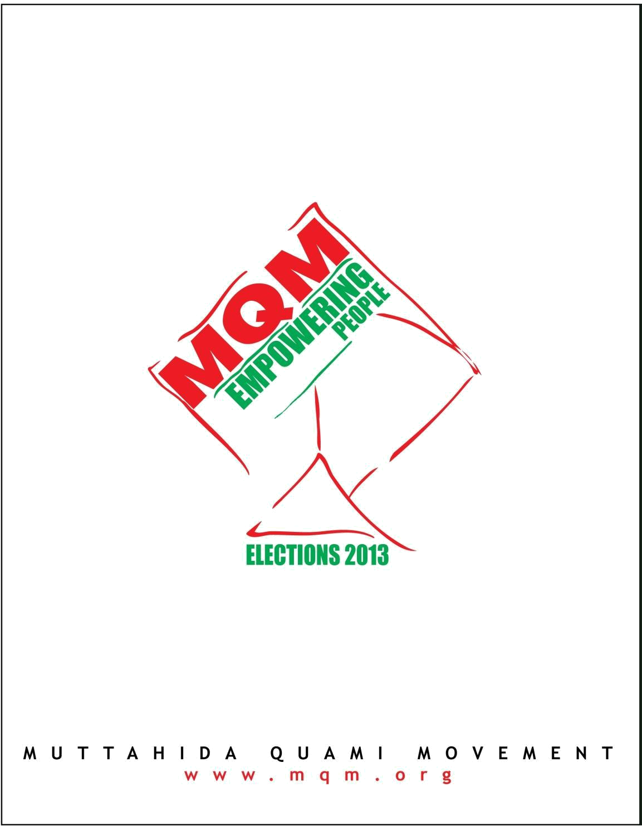
e-mail: ccc@mqmpakistan.org

